**WEEK – 04**

**Spring REST using Spring Boot 3**

**Superset ID: 6410372**

**Exercise 3:**

**Hello World RESTful Web Service**

**SOLUTION:**

* I created the HelloController class inside the com.cognizant.springlearn.controller package and annotated it with @RestController to make it a REST controller.
* I defined the sayHello() method with @GetMapping("/hello") so it handles GET requests at /hello.
* Inside the method, I printed START: sayHello() and END: sayHello() messages to track when the method starts and ends.
* The method returns the hardcoded string "Hello World!!".
* I used VS Code to run the application and tested the URL http://localhost:8083/hello in both Chrome and Postman to verify the response.

***SpringLearnApplicationTests.java:***

package com.cognizant.springlearn;

import org.junit.jupiter.api.Test;

import org.springframework.boot.test.context.SpringBootTest;

@SpringBootTest

class SpringLearnApplicationTests {

    @Test

    void contextLoads() {

    }

***Purpose:***

This code tests whether the Spring Boot application context loads correctly.  
It ensures there are no configuration or bean loading issues.  
This is a default health check for the application setup.

***HelloController.java:***

package com.cognizant.springlearn;

import org.junit.jupiter.api.Test;

import org.springframework.boot.test.context.SpringBootTest;

@SpringBootTest

class SpringLearnApplicationTests {

    @Test

    void contextLoads() {

    }

***Purpose:***

* Tests if the Spring Boot application context loads successfully.
* Helps identify any configuration or bean initialization errors.
* Confirms that the project setup is correct and ready to run.

***OUTPUT:***

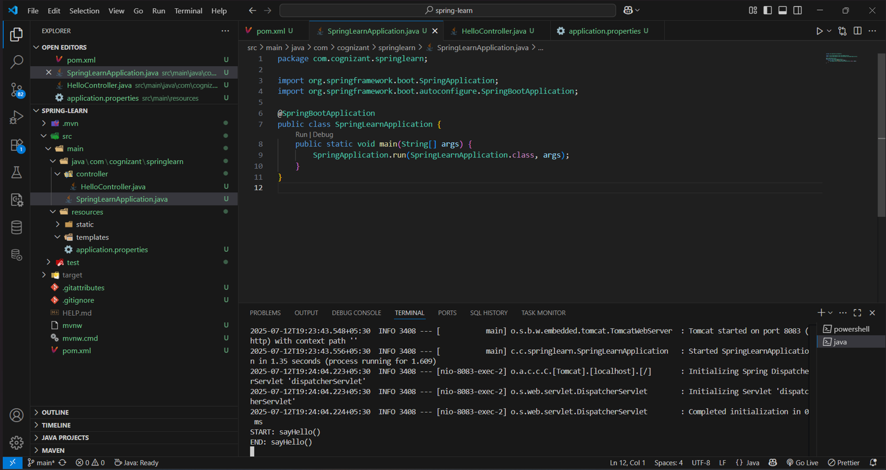

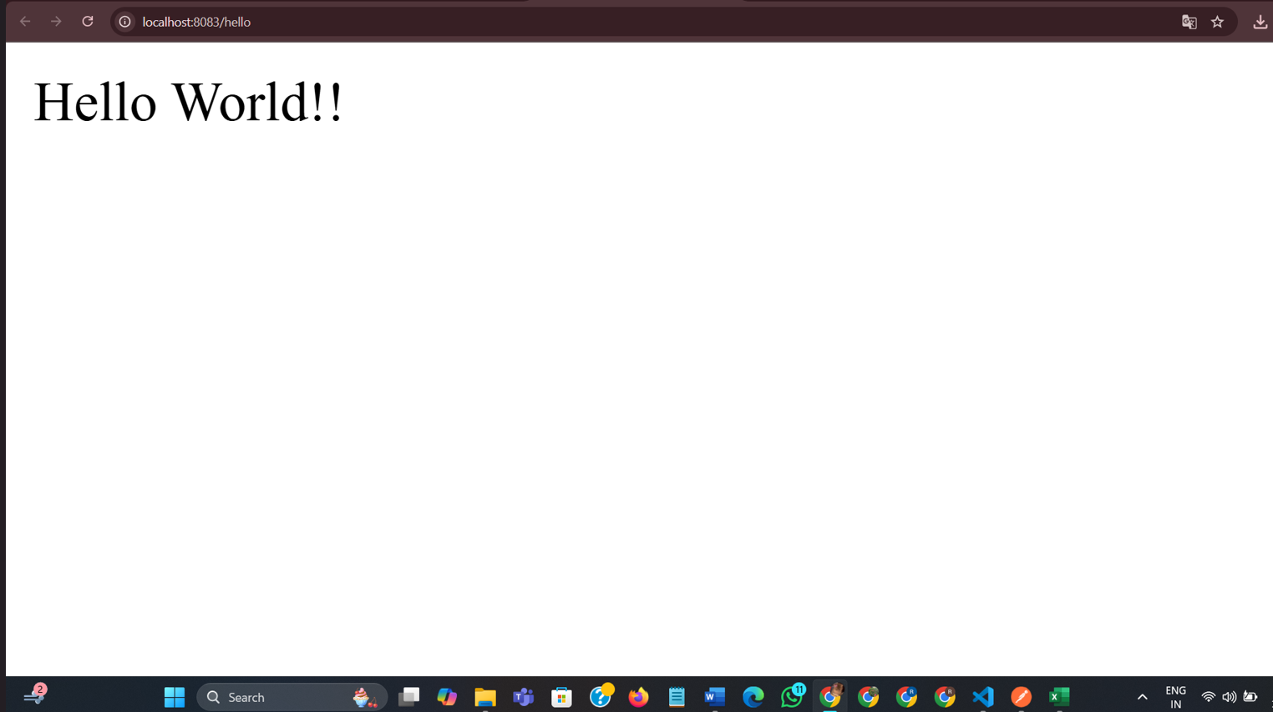

***EXPLANATION:***

* The code defines a REST controller (HelloController) that returns "Hello World!!" when a GET request is made to /hello.
* The SpringLearnApplication class runs the application, and SpringLearnApplicationTests ensures the Spring context loads without errors.
* This setup demonstrates a basic Spring Boot RESTful service with logging and testing, developed and executed in VS Code.

**___________________________________________________________________________**